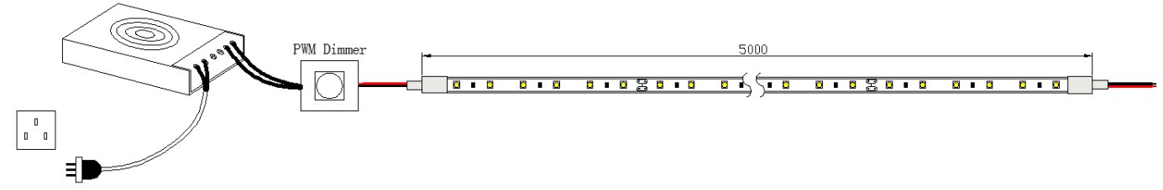

Installation steps：
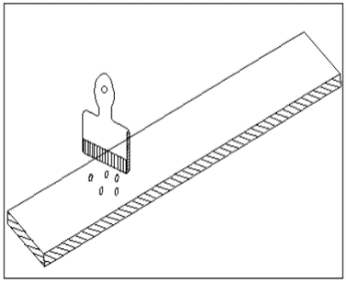
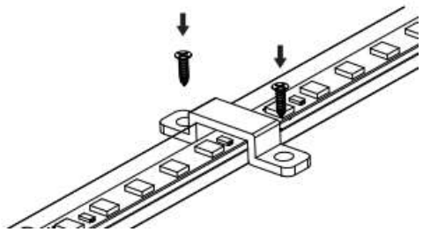
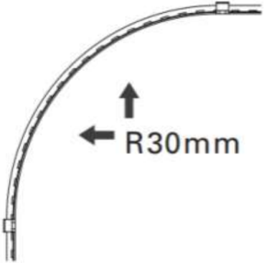
2
3
1

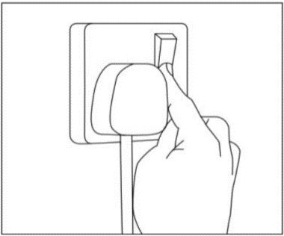
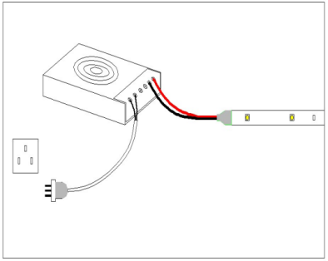
5
4

1. Clean the installation surface
2. Fix the light tape on the installation surface and secure it with clips
3. The radius of the curved installation surface should be greater than 30mm
4. Connect the LED tape to the LED driver and connect the input of the LED driver to the power supply
5. Turn on the power switch

Attention：
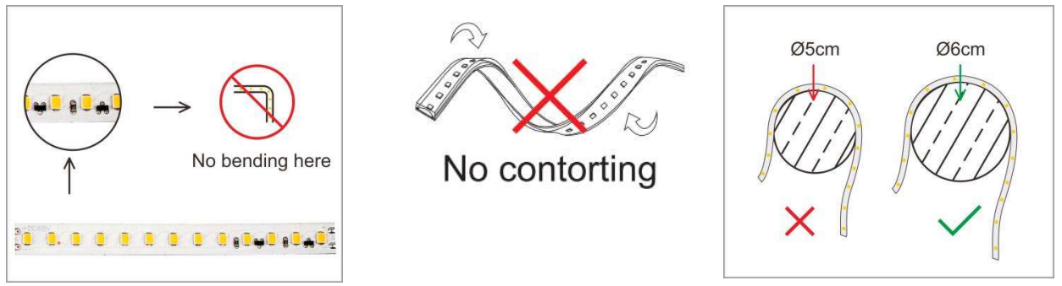
During the installation process, the diameter of the curved surface of the light tape should be greater than 6cm, and it should not be forcefully bent at right angles. When taking the light tape during the installation process, it is prohibited to fold, twist, or forcefully twist it. If the light tape is damaged due to human factors during the installation process, our company will not be responsible.
The diameter of the curved surface of the curved light tape shall not be less than 6cm
Do not twist the light tape
Do not bend the light strip at the LED

